ACADEMIC LEARNING PRODUCTIVITY APP



A Capstone Project Presented to the Faculty of the
College of Information and Communications Technology
St. John Paul II College of Davao
Davao City

In Partial Fulfillment
of the Requirements for the Degree
Bachelor of Science in Information Technology

By
BARBIELLE P. PAL
MARC LUIS I. LANDAZABAL

KAREN SHANE A. PRIETE, MIT
Adviser

May 2026

TABLE OF CONTENTS
TITLE PAGE i
TABLE CONTENTS ii
LIST OF FIGURES iii
LIST OF TABLES iv

Chapter |  | Page
1 | INTRODUCTION  Project Context  Statement of the Problem  Objectives  Scope and Limitations | 1  2  3  4  4
2 | REVIEW OF RELATED LITERATURES AND SYSTEMS  Review of Related Literature  Smart Scheduling and Task Optimization in Education  Time Efficiency and Academic Performance Enhancement  Role of Prescriptive Analytics in Student Decision-Making  Study Techniques for Effective Learning  Review of Related Systems (UPDATE TO CHANGE!)  Todoist: Planner & Calendar  Chaos Control 2: GTD Organizer  Focus Plant: Pomodoro Forest  Comparison Matrix | 5  5  5  6  7  9  12  12  13  14  15
3 | TECHNICAL BACKGROUND  Conceptual Framework  Software and Hardware Requirements  Prototype Description | 14  14  15  18
4 | RESULTS AND DISCUSSION  Data Gathering Procedures  System Implementation Overview  Prototype Evaluation and Analysis  Summary of Findings  Conclusion

REFERENCES 29

LIST OF FIGURES

Figure |  | Page
1 | Todoist: Planner & Calendar (by: Doist Inc.) | 9
2 | Chaos Control 2: GTD Organizer (by: Chaos Control) | 10
3 | Focus Plant: Pomodoro Forest (by: Shikudo – Walking and Focus Games) | 11
4 | IntelliPlan’s Conceptual Framework | 14
5 | IntelliPlan’s Welcome / Home Screen Page | 18
6 | IntelliPlan’s Class Schedule Interface / Task Input Page | 19
7 | IntelliPlan’s Study Recommendations Panel with Analytics Charts Page | 20
8 | IntelliPlan’s Focus Timer + Gamified Element Page (e.g., Plant Growing or Badges) | 21
9 | IntelliPlan’s Hydration Tracker / Wellness UI Page | 22
10 | IntelliPlan’s Group Project Kanban Board Page | 23
11 | IntelliPlan’s Student Dashboard Page (Charts, Task Completion, Calendar) | 24
12 | IntelliPlan’s Admin Dashboard Overview Page | 25
13 | IntelliPlan’s UI Design System / Figma Kit Screenshot | 26
14 | System Architecture Diagram | 27
15 | User vs Admin Flow Diagram | 28

LIST OF TABLES

Table |  | Page
1 | Related Systems Comparison Matrix | 12
2 | Software and Hardware Requirements of IntelliPlan | 15

Chapter 1
INTRODUCTION (GOOD)
The contemporary academic environment presents a complex array of challenges that significantly affect students’ productivity, time management, and overall academic performance. Lavy (2023) found that balancing multiple responsibilities such as attending classes, completing assignments, and participating in extracurricular activities often leads to poor prioritization and stress. Demmans Epp, Perfetti, Phirangee, and Hewitt (2020) further emphasized that although students rely on various online learning platforms, many continue to struggle with engagement, organization, and effective workload management. These challenges highlight the growing need for structured, technology-assisted learning approaches.
In the Philippine context, Barrot, Del Rosario, and Llenares (2021) reported that online learning presents numerous challenges for students, particularly those related to their home learning environments and digital literacy levels. Yu (2022) noted that the most significant issues faced by students were linked to distractions and limitations at home, while difficulties in technological literacy were less common. Miller (2020) emphasized that as academic workloads increased under remote and hybrid learning conditions, students found it harder to manage time, prioritize tasks, and sustain productivity. These challenges underscore the need for intelligent scheduling tools that can adapt to learning behaviors and improve time management.
To address these concerns, technological innovation has become an effective approach to improving academic performance and productivity. Gokul, Sakthivel, Manimaran, and Karthikeyan (2024) found that AI-driven scheduling tools and prescriptive analytics enhance time management by analyzing study habits, tasks, and goals. Likewise, Moleta and Teleron (2025) highlighted that smart scheduling apps can increase productivity by creating tailored study plans based on workloads and deadlines. Skulmowski and Xu (2021) further noted that such tools not only streamline time management but also reduce cognitive load, allowing students to focus more on learning. Integrating these approaches, IntelliPlan aims to help students organize their studies efficiently, balance responsibilities, and minimize cognitive strain through adaptive scheduling and data-driven recommendations.
Project Context (GOOD)
Guzmán-Valenzuela, Gómez-González, Rojas-Murphy Tagle, and Lorca-Vyhmeister (2021) stated that learning analytics (LA) is a rapidly growing field in higher education that focuses on collecting and analyzing student data to improve academic outcomes. However, while LA emphasizes prediction and data gathering, it often lacks meaningful pedagogical integration, which limits its overall effectiveness in enhancing the actual learning process. To bridge this gap, IntelliPlan incorporates prescriptive analytics alongside student-centered scheduling and personalized study strategies—specifically Pomodoro, Spaced Repetition, and Active Recall—to strengthen time management and improve study retention through adaptive and data-informed insights.
The project functions as an intelligent academic scheduling tool designed to assist students in prioritizing their academic tasks, managing their daily and long-term study schedules, and sustaining motivation through gamified progress systems. According to Lafleur (2024), integrating techniques such as Pomodoro, mind mapping, spaced repetition, and structured planning significantly enhances focus, productivity, and long-term retention. Furthermore, the system fosters collaboration by providing features for group scheduling, progress tracking, and shared task visibility through an intuitive visual dashboard. Offline functionality ensures accessibility even in limited connectivity environments, addressing one of the most common barriers faced by students in digital learning.
Developed as an Android-based mobile application, IntelliPlan prioritizes usability, flexibility, and accessibility to align with the growing preference for mobile-based academic support tools. Al-Rahmi, Al-Rahmi, Alturki, Aldraiweesh, Almutairy, and Al-Adwan (2022) highlighted that mobile learning applications can enhance student engagement, accessibility, and academic self-regulation—particularly when equipped with analytics-driven and user-centered designs. Through its combination of smart scheduling, adaptive analytics, and gamification, IntelliPlan serves as an integrated academic management platform that enables students to visualize their workloads, develop consistent and effective study habits, and adapt evidence-based techniques to their learning preferences—ultimately fostering balance, well-being, and improved academic productivity.
Statement of the Problem (GOOD)
Students often face challenges in managing their time effectively as they balance both academic and personal responsibilities, leading to stress and lower academic performance. Al-Mamary (2022) stated that students struggle with organizing tasks, managing workloads, and maintaining focus, which negatively affects their learning outcomes. Although existing learning management systems (LMS) provide access to learning materials, they lack the ability to provide personalized guidance, adaptive recommendations, and proactive task management. Similarly, Dindar, Suorsa, Hermes, Karppinen, and Näykki (2021) found that insufficient time management and self-regulation in online learning environments often lead to procrastination, disengagement, and reduced academic achievement. These issues emphasize the importance of developing more intelligent and adaptive educational tools that can support students in planning, organizing, and completing their academic tasks more efficiently.
In the Philippine context, the transition to online and blended learning has further revealed the limitations of current LMS platforms. Cavus, Mohammed, and Yakubu (2021) observed that many students struggled with navigation and accessibility, which resulted in reduced participation and engagement. Alenezi, Wardat, and Akour (2023) highlighted the increasing need for academic management systems that can effectively balance content delivery with tools that enhance productivity, engagement, and overall learning satisfaction.
LMS-related challenges also influence the level of student motivation and satisfaction. Peria, Candolita, Mahinay, Campos, and Buladaco (2021) found that the absence of interactive features, accessibility issues, and usability concerns negatively affect student engagement and learning outcomes. Rivera and Garden (2021) demonstrated that gamification increases engagement through goal-setting, rewards, and academic milestones, while Jhonlawi (2024) emphasized that adaptive scheduling helps students manage workloads effectively and boost productivity. Combining these approaches, the researchers identified the need for a mobile-based intelligent academic scheduler that integrates adaptive analytics, gamification, and collaboration — addressing both the cognitive and motivational aspects of learning, as supported by Demartini, Sciascia, Bosso, and Manuri (2024).
Objectives (GOOD)
The researchers aim to develop a smart scheduling mobile application that enhances the student’s academic learning productivity. Particularly, it aims to:
- design a smart scheduling system that allows students to organize class schedules, assignments, and collaborative tasks.
- integrate prescriptive analytics that recommends optimal study times based on user productivity patterns, past activities, and deadlines.
- incorporate gamification and study techniques (Pomodoro, Spaced Repetition, Active Recall) to promote effective learning habits.
Scope and Limitations (GOOD)
The project focuses on developing IntelliPlan, a mobile Android application designed to enhance student productivity through intelligent scheduling, prescriptive analytics, and interactive learning tools. It targets both college and senior high school students who need an efficient and user-friendly productivity aid. The app integrates smart scheduling, study technique modules, collaboration tools, focus timers, and a performance dashboard to help users manage their workload, organize study sessions, and monitor their academic progress. It will be developed using Android Studio, Firebase, Node.js, and Python, with Figma, GitHub, and Trello supporting design and project management. IntelliPlan aims to provide an adaptive, student-centered platform that promotes balanced study habits, consistent learning routines, and greater engagement.
However, the project also has several limitations. The initial version will run only on Android devices and require internet connectivity for synchronization, collaboration, and analytics, though basic scheduling features will remain available offline. Advanced AI-driven recommendations will be limited in early iterations and gradually improved through future updates. The app will not yet support integration with external calendars or learning management systems. Usability testing and large-scale validation will be conducted in later phases once the prototype is completed and user feedback is collected. Budget limitations may also restrict access to premium AI and cloud-based services. Despite these constraints, IntelliPlan serves as a strong foundation for future development, combining intelligent planning, adaptive study support, and collaboration tools to improve students’ academic organization and overall productivity.
Chapter 2
REVIEW OF RELATED LITERATURE AND SYSTEMS (GOOD)
Review of Related Literature
This section contains various reviews of related literature and studies, the technical background of which will discuss the project’s technicalities, the details of the technologies to be used, as well as the project’s relevance.
Smart Scheduling and Task Optimization in Education
The development of smart scheduling systems has become an essential focus in academic environments, addressing the complexities of student schedules. These systems aim to optimize time allocation based on individual needs and academic constraints. One such system proposed by Saeed and Fahim (2020) automates course registration processes and dynamically adjusts schedules based on student constraints, such as prerequisite courses and workload. By automating these tasks, students can focus more on learning rather than administrative duties, thus improving their academic performance. The implementation of such systems has shown positive outcomes in real-world applications, such as a study at Neelain University, where students reported an improvement in their GPAs due to better time management and optimized course scheduling.
In addition to academic scheduling, smart systems integrate a variety of intelligent features that take into account multiple variables, such as study habits, deadlines, personal preferences, and past academic performance. These systems are designed to reduce the cognitive load on students by automating the creation of their study and work schedules, allowing them to focus more on learning rather than spending excessive time on organizing their tasks. The integration of such features has been shown to significantly increase student productivity by organizing tasks in a manner that ensures that students allocate sufficient time to each activity, preventing overburdening and ensuring that deadlines are met. Moreover, intelligent scheduling systems are capable of dynamically adjusting the timetable to reflect any changes in a student’s availability or workload, making them more adaptable to the student's evolving needs. By prioritizing tasks based on urgency and importance, these systems help students make more informed decisions about how to allocate their time, ultimately contributing to greater academic success. As Haderer and Ciolacu (2022) highlight, these systems not only assist students in planning but also foster an environment where they can thrive academically while experiencing lower levels of stress and frustration.
Recent advances in hybrid scheduling algorithms further enhance the capabilities of smart scheduling systems. Shao, Song, and Wang (2023) introduced a hybrid approach combining Genetic Algorithms (GA) and Particle Swarm Optimization (PSO) for scheduling tasks with deadline constraints in distributed computing environments. These algorithms aim to tackle the complexity of scheduling problems, often characterized as NP-complete. In academic settings, such algorithms can optimize timetable generation and task prioritization, ensuring that students meet their deadlines and avoid overburdening themselves. These hybrid approaches have been found to improve the efficiency of scheduling systems, allowing them to handle complex task scheduling while optimizing resource allocation.
Time Efficiency and Academic Performance Enhancement
Time management plays a crucial role in students' academic success, well-being, and overall performance. Aeon, Faber, and Panaccio (2021) conducted a meta-analysis revealing a moderately strong relationship between time management and life satisfaction, academic performance, and work productivity. Their study found that students who manage their time effectively tend to perform better academically, experience higher life satisfaction, and cope with less stress. Interestingly, the research noted a small gender gap, with women managing time slightly better than men. This underscores the importance of embedding time management strategies into educational systems to enhance academic outcomes and student well-being.
Effective time management also has a significant positive impact on mental health. Poor time management, such as procrastination and disorganization, can lead to stress and burnout, negatively affecting academic performance. Holili, Mf, Widat, Listrianti, and Walid (2024) explored the impact of time management training on student performance at SMP Negeri 1 Proppo. Their study found that students who participated in structured time management training demonstrated better focus, task prioritization, and academic efficiency. These findings support the idea that structured planning interventions reduce stress and promote a balanced workload, leading to improved academic performance.
For working students, balancing academic responsibilities with professional commitments can be challenging. Pedroso, Aponte, Juanico, and West Visayas State University (2023) conducted a study on time management strategies for Filipino working students. Through interviews, they identified strategies such as structured routines, planning tools, and task prioritization. The study also emphasized the importance of personal initiative, adaptive scheduling, and institutional support in helping students navigate their academic and professional lives efficiently, reducing stress, and boosting productivity.
The use of mobile apps for time management is also gaining popularity as an effective intervention. Alhasani and Orji (2024) developed "SortOut," a mobile app designed to help students reduce stress by promoting efficient time management practices. The app utilizes the Transtheoretical Model (TTM), guiding students through problem-focused coping strategies that enhance time management behaviors. The study found that students using "SortOut" reported improved time management and increased self-confidence, demonstrating the positive role of digital tools in supporting students' time efficiency and well-being.
Role of Prescriptive Analytics in Student Decision-Making
Prescriptive analytics plays a crucial role in decision support systems, particularly in education, by helping students make more informed decisions regarding scheduling and task management. Wissuchek and Zschech (2024) conducted a comprehensive review of prescriptive analytics systems (PAS), highlighting their ability to leverage artificial intelligence (AI) and optimization techniques to provide actionable recommendations. These systems are designed to analyze various student-related factors such as behavior patterns, workload, and deadlines. In academic scheduling, PAS can suggest optimal study times, recommend task prioritization, and create efficient schedules tailored to each student's unique needs. This empowers students to make better decisions about when and how to allocate their time, ultimately improving their academic experience and performance.
Beyond time management, prescriptive analytics has been found to enhance productivity by tailoring study plans to individual students. According to Ramaswami, Susnjak, and Mathrani (2022), intelligent scheduling systems powered by prescriptive analytics analyze students' past performance, identifying patterns that can inform future study plans. By recommending study times based on when a student is most productive, these systems help students work smarter, not harder. Moreover, these systems factor in critical deadlines and personal preferences, ensuring that the study schedule is personalized and aligns with the student's needs. This type of data-driven system ensures that students are working efficiently and avoids overloading them, which in turn promotes a balanced academic workload and improves academic performance.
An additional advantage of prescriptive analytics in education is its ability to provide real-time, actionable feedback. Kurilovas (2018) emphasized the importance of real-time data processing in decision-making, especially in educational settings where the pace of work and student progress can vary significantly. PAS continuously monitors student progress, adjusting schedules and recommendations in real time. This dynamic nature helps students stay on track with their goals, adjusting for missed tasks or upcoming deadlines. Real-time feedback also plays a vital role in reducing procrastination and minimizing stress, as students can make quick adjustments to their schedules and avoid last-minute cramming or rushed work. The ongoing evolution of prescriptive analytics systems suggests they will continue to offer more advanced, data-driven solutions that adapt to the ever-changing demands of students' academic workloads.
The role of prescriptive analytics in educational decision-making extends beyond just time management, as it enables students to make better-informed choices about their overall academic strategy. Pashchenko, An, Hieu, Pashchenko, and Van Trong (2020) explored the use of intelligent technologies in decision-making support systems, noting that prescriptive analytics can aid in a range of academic decisions, from prioritizing assignments to selecting courses. These systems can help students not only manage their time more effectively but also improve their overall academic outcomes by providing insights into the most efficient ways to approach their studies. As prescriptive analytics continues to evolve, it is expected that these systems will become even more integrated into educational environments, offering increasingly sophisticated tools for students to optimize their academic performance and well-being.

Study Techniques for Effective Learning
Study techniques play a pivotal role in enhancing student productivity and academic performance. One widely used technique is the Pomodoro Technique, which encourages students to work in short, focused intervals followed by brief breaks. This technique helps maintain concentration and prevents burnout. Almalki, Alharbi, Al-Ahmadi, and Aljohani (2020) showed that Pomodoro-based tools for graduate students significantly reduced procrastination and improved academic focus. By structuring study time into manageable blocks, students are able to maintain high levels of productivity and avoid cognitive fatigue. This structured approach also helps students stay motivated and avoid the overwhelming feeling that often leads to procrastination.
Another popular method is spaced repetition, which involves revisiting material at increasing intervals to enhance long-term retention. Spaced repetition has been extensively researched and proven effective for improving memory and recall, particularly in language learning. Hanson and Brown (2019) found that mobile-assisted spaced-repetition tools were particularly effective for second-language learners, improving their retention and recall abilities over time. The method ensures that students engage with the material just before they are likely to forget it, reinforcing their knowledge and making studying more efficient. When integrated with other tools, spaced repetition can be tailored to a student's personal learning needs, maximizing its effectiveness.
Active recall is another technique that involves actively testing one’s knowledge instead of passively reviewing materials. Xu, Wu, Filip, Patel, Bernstein, Tanveer, Syed, and Kotroczo (2024) conducted a systematic review that demonstrated the significant academic benefits of active recall. By engaging in frequent self-testing, students strengthen their memory and understanding of the material. This method has been shown to be particularly beneficial for students studying for exams, as it promotes better retention and quicker retrieval of information. Active recall helps reduce the need for cramming by providing students with ongoing, low-pressure opportunities to check their understanding.
Retrieval practice is a closely related technique to active recall and involves intentionally retrieving information from memory to strengthen neural connections and enhance long-term learning. Bertilsson, Stenlund, Wiklund-Hörnqvist, and Jonsson (2020) highlighted that retrieval practice is beneficial for all students, although its effectiveness can vary depending on individual differences such as cognitive ability and prior knowledge. Regularly engaging in retrieval practice helps reinforce learning and improves the ability to recall information under pressure, which is particularly useful for exams and assessments.
In addition to these cognitive techniques, gamification has become an increasingly popular strategy to boost student motivation and engagement. Saleem, Noori, and Ozdamli (2021) discussed how gamified elements, such as rewards and leaderboards, can significantly enhance student engagement and motivation. By turning learning into a game, students become more committed to completing their tasks and achieving milestones. Gamification helps to maintain interest and provides a sense of achievement, which can be particularly beneficial for students struggling with motivation or those facing large, intimidating assignments. The integration of game mechanics within study plans makes the learning process more interactive and enjoyable, leading to better retention and a more positive attitude towards studying.
Another effective technique for improving academic performance is collaborative learning, which involves working together with peers to solve problems and discuss concepts. Rahman, Masitoh, and Mariono (2022) found that collaborative learning enhances both creative and critical thinking skills. By discussing ideas and tackling problems in groups, students can gain multiple perspectives, improve their understanding, and learn to work more effectively with others. This technique is especially useful in subjects requiring complex problem-solving, as it allows students to combine their knowledge and strengths. Peer learning fosters an environment of shared responsibility and helps students deepen their understanding of difficult concepts.
Concept mapping is another effective visual technique used to organize and structure information. Machado and Carvalho (2020) examined the benefits and challenges of concept mapping in higher education, noting that it aids in the visualization of relationships between different ideas. This technique helps students better understand complex concepts and see how various pieces of information fit together. By mapping out the content, students can identify key themes, make connections, and organize their thoughts more clearly. Concept mapping can also help with exam preparation by providing a clear and organized visual representation of the material.
For some students, managing tasks effectively is essential to avoid procrastination and ensure timely completion. One technique designed to manage this is task batching or joint batching, which involves grouping similar tasks together to minimize task-switching and improve efficiency. Cang, Chen, and Huang (2024) applied task batching in high-throughput scheduling for multiuser systems and found that it increased operational efficiency by reducing delays and optimizing resource allocation. For students, batching related study tasks can reduce the cognitive load of switching between different types of activities, allowing for better focus and improved productivity during study sessions.
Lastly, the Two-Minute Rule is a simple yet effective approach to overcome procrastination by committing to work on a task for just two minutes. Shnayder-Adams and Sekhar (2021) emphasized the effectiveness of micro-habits for life-long learning, explaining that starting small can lead to larger, more sustained efforts over time. By committing to small, manageable tasks, students can avoid feeling overwhelmed and gain momentum, making it easier to tackle larger tasks as they build a habit of consistent work. This technique has been shown to reduce procrastination and increase overall productivity by focusing on the initial step of any task.

Review of Related Systems
This chapter presents a review of existing systems relevant to the development of the proposed smart scheduler with prescriptive analytics. The differences and similarities of each system will also be discussed. This helps the researchers distinguish the edge of the developed scheduler from the existing systems.
Todoist: Planner & Calendar
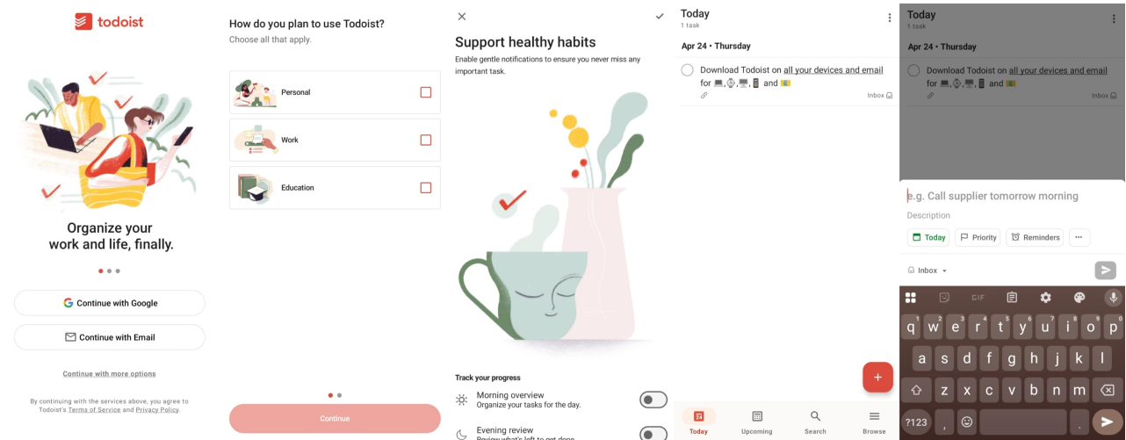
Figure 1. Todoist: Planner & Calendar (by: Doist Inc.)
(Image Source: https://play.google.com/store/apps/details?id=com.todoist)
Todoist is a widely used productivity application that offers a streamlined interface for organizing tasks, setting reminders, and managing both personal and academic schedules. It features intelligent task prioritization, recurring tasks, and smart suggestions that enable users to manage workloads efficiently. Todoist supports integration with calendars and productivity platforms, making it a robust tool for users aiming to stay organized across multiple areas of responsibility.
While Todoist is highly effective in general productivity, IntelliPlan distinguishes itself by being academically tailored for students, integrating prescriptive analytics based on productivity patterns, academic performance, and wellness data. Unlike Todoist, which relies more on manual input and general planning features, IntelliPlan automatically recommends personalized study sessions, optimal study hours, and wellness tips using machine learning models. This student-focused design provides a more targeted solution for managing coursework, exams, and group projects efficiently.

Chaos Control 2: GTD Organizer
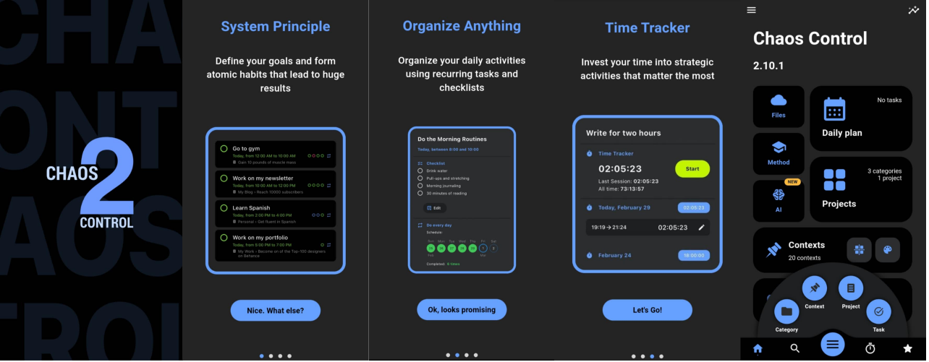
Figure 2. Chaos Control 2: GTD Organizer (by: Chaos Control)
(Image Source: https://play.google.com/store/apps/details?id=com.tarasovmobile.cc2)
Chaos Control 2 is a productivity and task management app built around the principles of Getting Things Done (GTD), a well-known methodology for organizing tasks and minimizing stress. The app allows users to create projects, break tasks down into manageable actions, and organize tasks into categories for enhanced focus. It also includes scheduling features and cloud synchronization to support task tracking across devices.
While Chaos Control focuses on task management using the GTD methodology, IntelliPlan offers a student-centric approach with features like class schedule planning, deadline tracking, and gamified study assistance. It helps students organize academic commitments, provides timely reminders, and incorporates techniques like the Pomodoro method and spaced repetition to boost focus. Additionally, IntelliPlan helps alleviate student stress by promoting a balanced academic schedule and offering wellness features such as hydration and focus reminders. Unlike Chaos Control, IntelliPlan supports collaboration for group projects, allowing students to share schedules and track progress. Its visual dashboards and real-time insights offer personalized analytics, while its AI adapts to students' learning styles, providing tailored recommendations. By combining adaptive, collaborative, and data-driven features, IntelliPlan is a more specialized tool for boosting productivity in the academic context.

Focus Plant: Pomodoro Forest
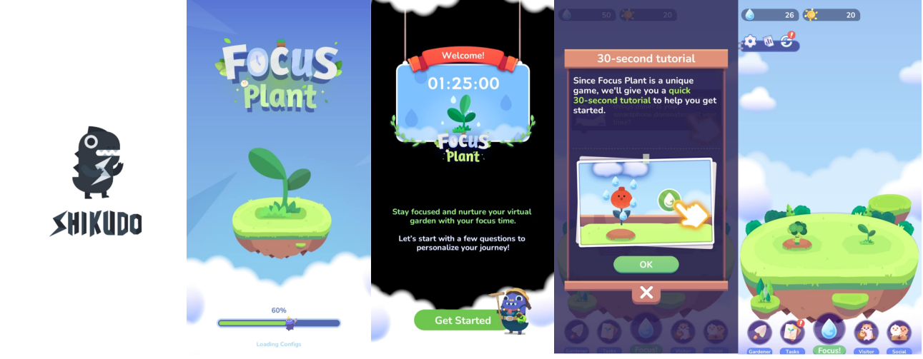
Figure 3. Focus Plant: Pomodoro Forest (by: Shikudo – Walking and Focus Games)
(Image Source: https://play.google.com/store/apps/details?id=com.shikudo.focus.google)
Focus Plant merges time management with gamification by integrating the Pomodoro Technique into a visually engaging environment. Users stay focused by growing virtual plants in a calming digital garden—each focus session contributes to plant growth, while distractions cause withering. The app also includes daily streak tracking and reward systems that encourage consistent study habits.
Although Focus Plant excels in creating a motivating and visually engaging experience with its Pomodoro-based approach, its scope is mainly limited to focus sessions and habit tracking. The app uses a digital garden where users grow virtual plants as a reward for staying focused, but lacks the tools needed for managing academic responsibilities. In contrast, IntelliPlan goes beyond Pomodoro timing by integrating academic scheduling, personalized study recommendations, and prescriptive analytics. It helps students organize workload, track deadlines, and optimize study habits with features like spaced repetition and mind-mapping, while also promoting well-being through hydration reminders. IntelliPlan’s real-time analytics and adaptive scheduling provide insights into study patterns, helping students prioritize tasks, while its collaboration tools enhance group work by allowing students to synchronize schedules and track progress. By combining productivity features with collaboration and health tools, IntelliPlan offers a more holistic platform that better supports student success than Focus Plant.

Comparison Matrix (GOOD)
The table below illustrates a feature-based comparison between the proposed system, IntelliPlan, and three existing productivity applications. A check mark () indicates that the feature is fully supported by the system, while a cross mark (×) signifies that the feature is not available.
Table 1. Related Systems Comparison Matrix
Feature / Criteria | Todoist: Planner & Calendar | Chaos Control 2: GTD Organizer | Focus Plant: Pomodoro Forest | IntelliPlan (Proposed System)
Academic Scheduling Support | × | × | ×
Prescriptive Analytics / AI-Powered Recommendations | × | × | ×
Gamification / Achievement System | ×
Collaboration / Group Scheduling |  | × | ×
Offline Capability
Progress Visualization / Dashboard | ×
Customization / Flexibility |  |  | ×
Multi-Study Technique Integration (Pomodoro, Spaced Repetition, Active Recall) | × | ×
Email verification

Table 1 compares IntelliPlan with three well-known productivity tools—Todoist, Chaos Control 2, and Focus Plant—across major productivity and academic support features. While Todoist and Chaos Control 2 provide strong general task management capabilities, they lack academic-oriented functions such as prescriptive analytics, study technique modules, and collaborative features that support group-based tasks. Focus Plant, on the other hand, offers gamification through Pomodoro timers, but its scope is limited to individual time tracking and lacks scheduling, analytics, or collaboration functions that are essential for students managing multiple academic responsibilities.
In contrast, IntelliPlan distinguishes itself as a comprehensive, student-focused productivity platform that integrates smart scheduling for academic activities, prescriptive analytics for recommending optimal study periods and workload distribution, and multiple study techniques such as Pomodoro, Spaced Repetition, and Active Recall. The system also incorporates gamification elements to motivate users through rewards and achievements, as well as collaborative tools that allow users to manage shared tasks and monitor group progress efficiently. Moreover, IntelliPlan’s adaptive and data-driven design provides personalized learning support and insight-driven recommendations, ensuring that the user experience remains both efficient and engaging. Through these combined features, IntelliPlan is positioned not merely as a task organizer but as a holistic academic productivity companion tailored to the needs of both college and senior high school students.

Chapter 3
TECHINICAL BACKGROUND
The systematic and technical aspects that will be used in this system are discussed in this chapter.
Conceptual Framework (Ilisunon na part)
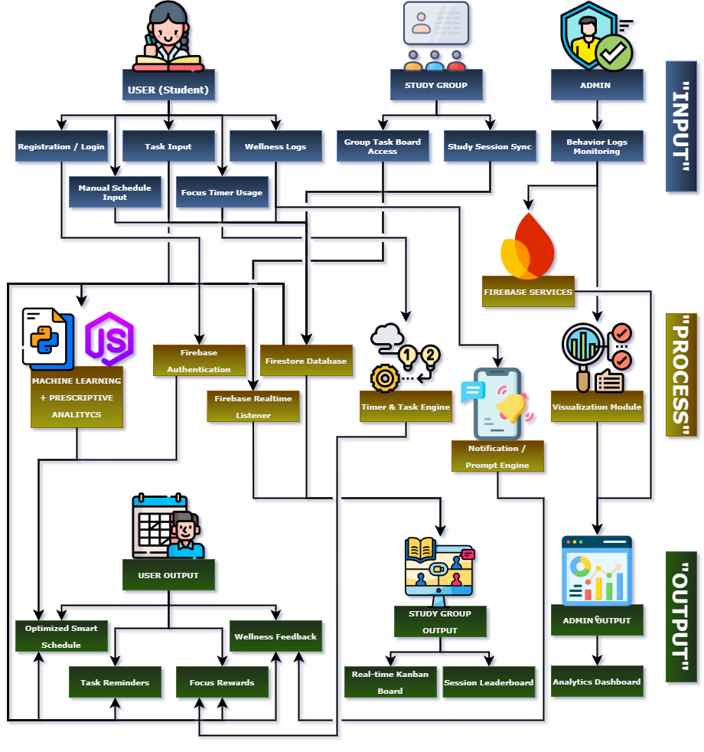
Figure 4. IntelliPlan’s Conceptual Framework
To utilize IntelliPlan, students or study group members are required to install the mobile application and register an account using personal academic credentials. Once registered, users log in and begin interacting with the system through an intuitive mobile interface. The user then inputs essential information, including schedules (classes, tasks, and activities), study habits, group collaboration details, and academic goals. Health data may also be optionally recorded to support wellness recommendations. These inputs are securely stored and synchronized via Firebase to ensure consistent data access. The system then processes this information through a prescriptive analytics engine developed using Python and machine learning algorithms, which analyzes behavioral patterns and academic trends. This engine works in tandem with an optimization logic module that prioritizes tasks based on urgency and importance. From these processes, the application generates several personalized outputs such as a dynamic schedule tailored to the user's academic and wellness needs, a ranked list of tasks, a visual dashboard with performance insights, targeted study session recommendations, and automated notifications including productivity prompts and wellness tips. Through this end-to-end structure—from user registration and input, to intelligent processing and actionable outputs—IntelliPlan effectively supports students in achieving academic efficiency and balance.
Software and Hardware Requirements (GOOD)
This section outlines the essential software, hardware, and related technologies required for the development, deployment, and usage of IntelliPlan. Each component has been selected to ensure reliable performance, scalability, and accessibility, particularly for student users on Android platforms.
Table 2. Software and Hardware Requirements of IntelliPlan
Category | Component / Tool | Description
Software Requirements | Android Studio | Primary IDE for building the Android app; supports Java and Kotlin, includes emulator, debugger, and Firebase integration.
 | Firebase | Backend-as-a-Service for authentication, real-time database, cloud storage, and notifications; enables device sync and secure data handling.
 | Python (Scikit-learn, Pandas) | Used for prescriptive analytics; Scikit-learn handles machine learning models, while Pandas is used for data processing and behavior pattern analysis.
 | Node.js | Middleware that handles API requests and serves predictions from Python models to the mobile frontend via RESTful APIs.
 | Figma & Canva | UI/UX design tools; Figma for wireframes and prototyping, Canva for creating icons and visual assets.
 | Git & GitHub | Version control system and remote code repository; used for collaboration, tracking, and integration management.
 | Firebase Test Lab & Android Emulator | Testing tools; used for cloud-based testing on real/virtual devices and local debugging during development.
API Integrations | Firebase Services (Firestore, Auth, FCM) | Integrated into the backend layer; Firestore handles real-time data storage, Firebase Auth manages secure user authentication, and Firebase Cloud Messaging (FCM) delivers push notifications to users.
 | REST API (Internal Node.js ↔ Python) | Custom internal API facilitating communication between the Node.js middleware and Python-based analytics engine. Enables data transfer and retrieval of productivity recommendations and insights.
 | Google Calendar API | External API for future integration; allows syncing of academic schedules and events across devices, enhancing time management features within the app.
 | NewsAPI | External content API integrated into the backend to fetch motivational news and productivity articles, which are displayed on the app dashboard to boost user engagement.
 | Android Jetpack Components | Set of official Android libraries used on the frontend for UI navigation, background tasks, and lifecycle management. Ensures modern, efficient, and maintainable app structure.
Hardware Requirements | Android Smartphones | Target user devices; must run Android 8.0+ with at least 2 GB RAM, 200 MB free storage, and support background tasks and internet access.
 | Developer Workstations | Development and testing machines; minimum specs include Intel i5/Ryzen 5, 8 GB RAM, 256 GB SSD, running Windows 10+, macOS, or Linux.
 | Internet Connectivity | Required for real-time sync with Firebase, API calls, app deployment, and collaboration via GitHub.
 | Cloud Hosting (Optional) | For offloading ML computations; requires cloud server with ≥2 vCPUs, 4 GB RAM, and Python environment (e.g., Google Cloud, AWS, or Heroku).

Prototype Description (To be modified)
This section presents the visual and functional design of the IntelliPlan mobile prototype, which demonstrates the complete user flow from onboarding to task management and analytics. The prototype is built around clarity, usability, and engagement, combining intelligent scheduling, adaptive learning tools, and gamified motivation within a dark-themed, minimalist interface.
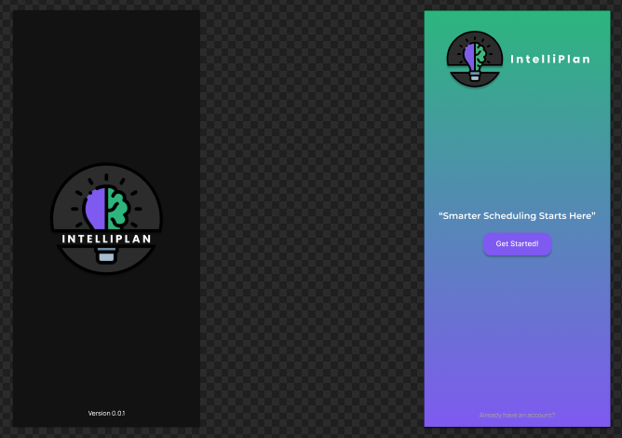
Figure 5 & 6. IntelliPlan Splash Screen (Intro Page) & Welcome Screen
The prototype begins with a simple splash screen displaying the IntelliPlan logo and tagline, “Smarter Scheduling Starts Here,” establishing the app’s brand identity and purpose. Following this is the Welcome Screen, which introduces users to the app and provides access to sign-in or registration options. The layout balances visual appeal and simplicity, using soft gradients and modern typography to create a focused and professional first impression.
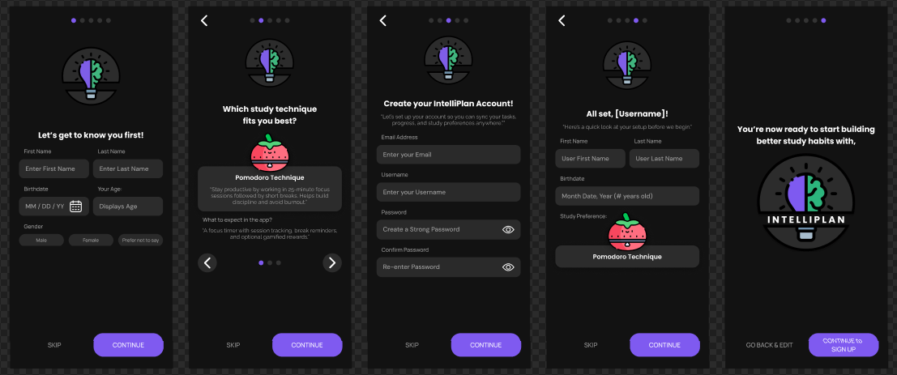
Figure 7. Registration Page
The Registration Page collects essential user information such as name, email, and password, while also allowing the user to select a preferred study technique, including Pomodoro, Spaced Repetition, or Active Recall. This feature helps the system personalize the user’s experience from the beginning, tailoring scheduling and productivity recommendations based on learning preferences. The layout emphasizes simplicity and clarity, ensuring users can complete the registration process smoothly and without confusion.
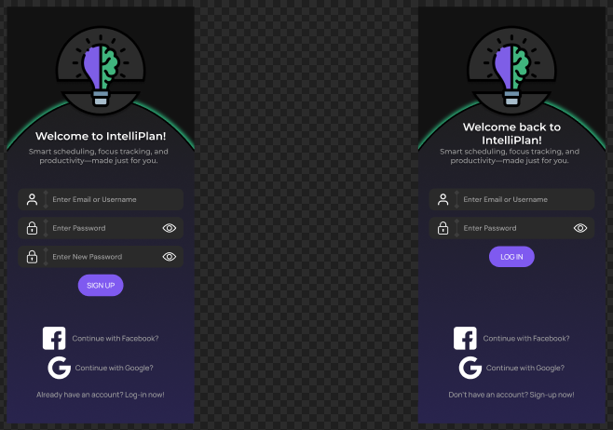
Figure 8 & 9. Sign-In / Log-In & Sign-Up Page
The Sign-In Page provides secure authentication options through both email and Google accounts. Its design maintains consistency with the overall dark-themed interface, featuring clean form fields, legible typography, and accessible button placements. To promote usability, the page includes options such as “Forgot Password” and clear error prompts, ensuring a seamless login experience. The minimal and structured layout encourages ease of access while maintaining professional visual balance.
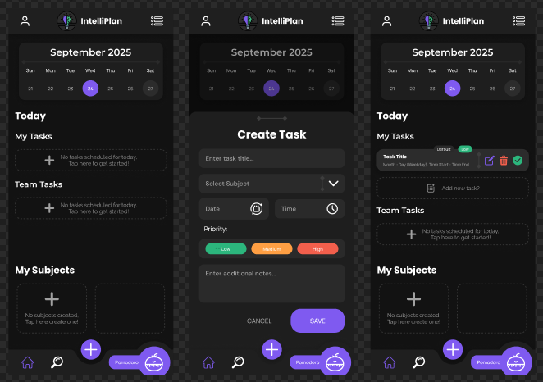
Figure 9. Home Interface
Upon login, users are directed to the Home Page, the central hub of IntelliPlan. It displays upcoming tasks, academic activities, and ongoing projects in a clear, organized layout. A floating action button (FAB) at the bottom center expands into a radial menu for quick access to five main sections: Task Scheduling, Gamification, Collaboration, Dashboard, and Settings. A Study Technique button at the bottom right displays the user’s chosen method—Pomodoro, Spaced Repetition, or Active Recall—and provides quick access to related timers or study logs. The interface prioritizes simplicity and smooth navigation, promoting focus and ease of use.
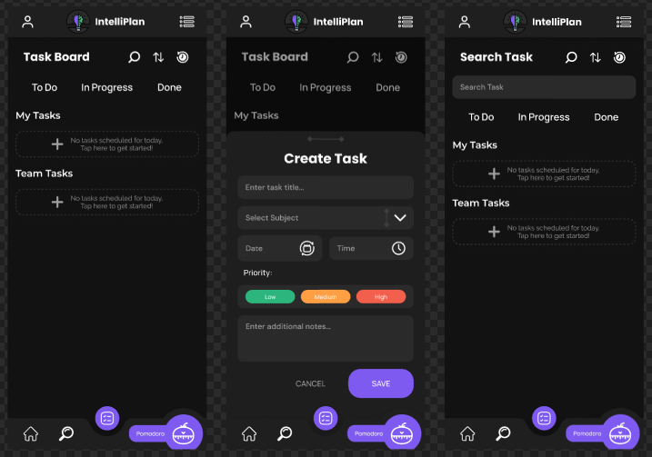
Figure 10. Task Scheduling Section
The Task Scheduling section provides a comprehensive task management system with a Kanban-style layout for tracking ongoing, completed, and archived tasks. Users can add, edit, search, and sort tasks for better organization and accessibility. A dedicated task history view allows users to review past activities and monitor productivity trends over time. Through its intuitive interface, this feature helps students efficiently manage academic workloads and maintain consistent progress.
Figure 11. Gamification and Achievements Section
The Gamification section enhances motivation through progress milestones, achievements, and a leveling system. By rewarding consistency and task completion, IntelliPlan encourages positive study habits, engagement, and sustained productivity, turning routine academic activities into a rewarding experience.

Figure 12. Collaboration Interface
The Collaboration section enables users to share tasks, coordinate group projects, and monitor collective progress in a shared workspace. This feature fosters teamwork, accountability, and efficient communication among students, making group activities more structured and transparent.

Figure 13. Dashboard Interface
The Dashboard presents key performance analytics, including task completion rates, productivity graphs, and time distribution summaries. It helps users evaluate study habits, identify areas for improvement, and maintain balanced routines through clear, data-driven insights.

Figure 14. Settings Interface
The Settings section allows users to personalize their IntelliPlan experience by adjusting preferences such as study technique selection, theme customization, and profile management. The dark-themed interface, paired with smooth transitions and minimalist visuals, enhances focus and reduces visual fatigue during extended study sessions.
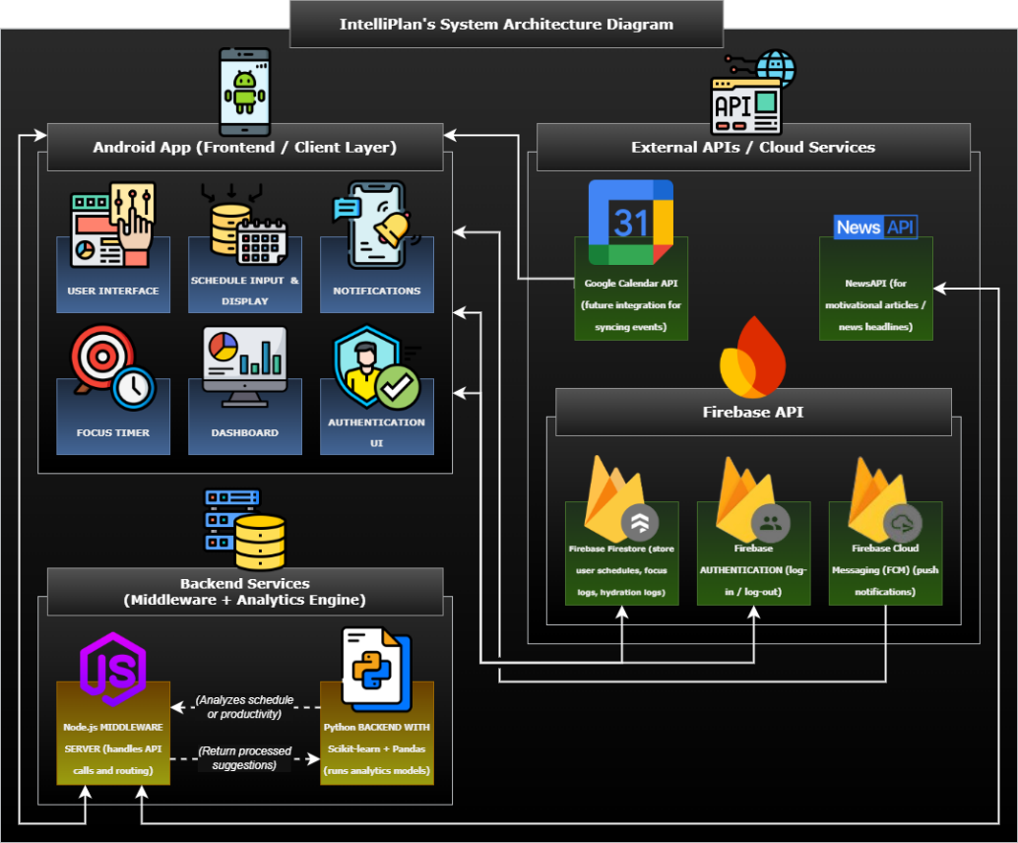
Figure 15. System Architecture Diagram
The system architecture of IntelliPlan is structured into three tiers: the Frontend, Backend Services, and External APIs & Cloud Services. The Android mobile interface serves as the user-facing layer, handling inputs, visualization, and interaction. The backend, built on Node.js and Firebase, acts as the central hub, processing user data and connecting to the machine learning engine (Python-based with Scikit-learn and Pandas) for personalized recommendations. External APIs such as Google Calendar and NewsAPI provide real-time syncing and motivational content. Together, this layered structure enables a responsive, intelligent, and scalable productivity platform.

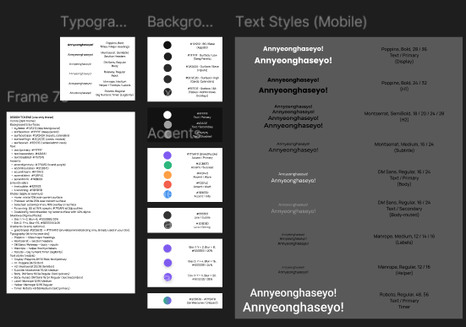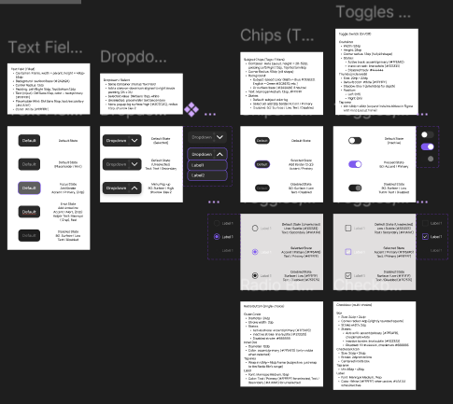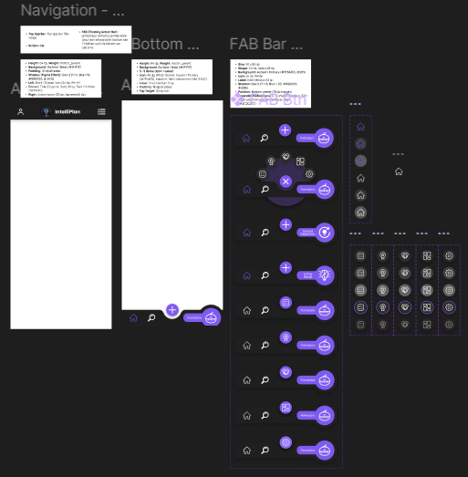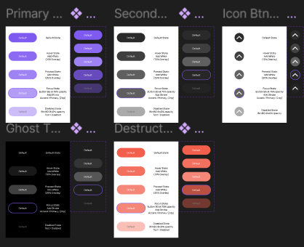
Figure n. UI Design System (Figma Kit Overview)
The IntelliPlan UI Design System, created in Figma, defines the complete visual and interactive language of the application. It contains a detailed set of style foundations and reusable components to ensure consistency across screens. The design kit includes four main areas: typography, color palettes, component states, and navigation patterns. Typography is standardized with multiple font pairings such as Poppins, Montserrat, DM Sans, Manrope, and Roboto, each assigned specific roles for titles, headers, body text, and timers. The color system is divided into background, surface, and accent layers, primarily using shades of black, gray, violet, and teal to maintain contrast and readability in dark mode. Component libraries include various button styles (primary, secondary, ghost, icon, and destructive), text fields, dropdowns, chips, toggles, and navigation bars. Each component features active, hover, and pressed states designed for clarity and accessibility. The FAB bar and bottom navigation define the app’s main interaction structure, providing users with quick access to key tools. Altogether, this design system establishes a scalable, cohesive, and user-centered visual framework that unifies IntelliPlan’s entire interface.

Chapter 4 (To be modified)
METHODOLOGY
The methodologies and procedures used to finish the research study were presented in this chapter. It encompassed the stage of the development process. We also talked about the system's development model, requirements, design, development, testing, and user review.
Data Gathering
The researchers gathered information using both qualitative and quantitative methods to acquire a deeper understanding of the challenges that students face in managing their academic responsibilities and time effectively. Since the study centers on developing a mobile application for academic learning productivity, the target respondents were students who experience issues related to time management, procrastination, academic workload, and overall study productivity.
To begin, the researchers conducted informal interviews and focused discussions with fellow students to identify recurring academic difficulties. During the interviews and group conversations, many students admitted that they kept running into the same problems with their studies. For example, they talked about having several deadlines piling up at once, finding it hard to decide which task to finish first, and easily losing focus while studying. Some also mentioned how tough it is to balance schoolwork with personal or family responsibilities. These responses gave the researchers a clearer picture of what students actually go through in their day-to-day academic life. To reach more students, surveys were also handed out. The survey asked about study habits, learning difficulties, and what tools they currently use to manage their schedules. A number of students said they tried using reminders, simple task lists, or even the Pomodoro technique. Others admitted they didn’t use any method at all. The survey results showed that problems like procrastination, lack of motivation, forgotten deadlines, and not making use of digital study tools are still very common among students.

The researchers then compared these findings with existing studies and productivity apps, as discussed in Chapter 2. Earlier research (Aeon, Faber, & Panaccio, 2021; Alhasani & Orji, 2024; Rivera & Garden, 2021) already pointed out that good time management and gamified learning can help students stay motivated and do better in school. These studies also backed up the results of our interviews and surveys, showing that students really need a tool that combines scheduling, focus timers, learning analytics, and gamification features.
By piecing together the results from the interviews, surveys, and the related studies, the researchers were able to see the bigger picture of the issues faced by students. This became the starting point for creating the proposed academic productivity app, with features designed specifically to respond to the problems and needs that were identified.
Data Flow Diagram
Figure 6. Data Flow Diagram-Admin
Figure 7. Data Flow Diagram-User

User Requiremnt Specification
Functional Requirement
Table 3
Functional Requirements
Analysis
System Design
Input-Process-Output
Figure 8. Input-Process-Output
Flowchart
Figure 9. Flowhart-Admin
Figure 10. Flowhart-User
Data Models-Database Design
Entity Relationship Diagram
Figure 11. Entity Relationship Diagram
Data Dictionary
Table 4
Data Dictionary for ‘Users’ Entity
Table 5
Data Dictionary for ‘’ Entity
Table 6
Data Dictionary for ‘’ Entity
Table 7
Data Dictionary for ‘’ Entity
Table 8
Data Dictionary for ‘’ Entity
Use Case Diagram
Figure 12. Use Case Diagram
Architecture Design
Figure 13.Architecture Design
Prototype

REFERENCES
Aeon, B., Faber, A., & Panaccio, A. (2021). Does time management work? A meta-analysis. PLoS ONE, 16(1), e0245066. https://pmc.ncbi.nlm.nih.gov/articles/PMC7799745/pdf/pone.0245066.pdf
Alenezi, M., Wardat, S., & Akour, M. (2023). The need of Integrating digital education in higher Education: challenges and opportunities. Sustainability, 15(6), 4782. https://doi.org/10.3390/su15064782

Alhasani, M., & Orji, R. (2024). Promoting Stress Management among Students in Higher Education: Evaluating the Effectiveness of a Persuasive Time Management Mobile App. International Journal of Human-Computer Interaction, 1–23 .https://www.researchgate.net/publication/377232605_Promoting_Stress_Management_among_Students_in_Higher_Education_Evaluating_the_Effectiveness_of_a_Persuasive_Time_Management_Mobile_App
Al-Mamary, Y. H. S. (2022). Why do students adopt and use Learning Management Systems?: Insights from Saudi Arabia. International Journal of Information Management Data Insights, 2(2), 100088. https://doi.org/10.1016/j.jjimei.2022.100088

Almalki, K., Alharbi, O., Al-Ahmadi, W., & Aljohani, M. (2020). Anti-procrastination online tool for graduate students based on the Pomodoro technique. In Lecture notes in computer science (pp. 133–144). https://doi.org/10.1007/978-3-030-50506-6_10

Al-Rahmi, A. M., Al-Rahmi, W. M., Alturki, U., Aldraiweesh, A., Almutairy, S., & Al-Adwan, A. S. (2022). Acceptance of mobile technologies and M-learning by university students: An empirical investigation in higher education. Education and Information Technologies, 27(6), 7805–7826. https://doi.org/10.1007/s10639-022-10934-8

Barrot, J. S., Del Rosario, L. S., & Llenares, I. I. (2021). Students’ online learning challenges during the pandemic and how they cope with them: The case of the Philippines. Education and Information Technologies, 26(6), 7321-7338. https://doi.org/10.1007/s10639-021-10589-x

Bertilsson, F., Stenlund, T., Wiklund-Hörnqvist, C., & Jonsson, B. (2020). Retrieval practice: beneficial for all students or moderated by individual differences? Psychology Learning & Teaching, 20(1), 21–39. https://doi.org/10.1177/1475725720973494

Cai, Z., Wu, H., Li, W., Hubei Vocational College of Bio-Technology, & School of Computer Science, South-Central Minzu University. (2024). Smart scheduling and resource allocation algorithms in digital Twin Campus. In Journal of Electronics and Information Science (Vols. 2–2, p. 169). Clausius Scientific Press, Canada.https://www.clausiuspress.com/assets/default/article/2024/09/05/article_1725532664.pdf

Cang, Y., Chen, M., & Huang, K. (2024). Joint Batching and Scheduling for High-Throughput Multiuser Edge AI with Asynchronous Task Arrivals. IEEE Transactions on Wireless Communications, 23(10), 13782–13795. https://doi.org/10.1109/twc.2024.3404811

Cavus, N., Mohammed, Y. B., & Yakubu, M. N. (2021). Determinants of Learning Management Systems during COVID-19 Pandemic for Sustainable Education. Sustainability, 13(9), 5189. https://doi.org/10.3390/su13095189

Chaos Control. (2023). Chaos Control 2: GTD Organizer (Version 2.9.3) [Mobile App]. Google Play Store. https://play.google.com/store/apps/details?id=com.tarasovmobile.cc2

Demartini, C. G., Sciascia, L., Bosso, A., & Manuri, F. (2024). Artificial Intelligence Bringing Improvements to Adaptive Learning in Education: a case study. Sustainability, 16(3), 1347. https://doi.org/10.3390/su16031347

Demmans Epp, C., Perfetti, C. A., Phirangee, K., & Hewitt, J. (2020). Learning management system and course influences on student actions and learning experiences. Educational Technology and Research Development, 68(6), 3263-3297. https://doi.org/10.1007/s11423-020-09821-1

Dindar, M., Suorsa, A., Hermes, J., Karppinen, P., & Näykki, P. (2021). Comparing technology acceptance of K‐12 teachers with and without prior experience of learning management systems: A Covid‐19 pandemic study. Journal of Computer Assisted Learning, 37(6), 1553–1565. https://doi.org/10.1111/jcal.12552

Doist Inc. (2012). Todoist: Planner & Calendar (Version v11712) [Mobile App]. Google Play Store. https://play.google.com/store/apps/details?id=com.todoist

Dy, E. J. D., PhD. (2023). Unfolding crisis management in private higher education institutions. In DDC Professional Journal (Vol. 4, Issue 1, p. 8) [Journal-article; Print]. Davao Doctors College. https://www.davaodoctors.edu.ph/wordpress/wp-content/uploads/2023/09/DDC-Professional-Journal-Vol-4No1-.pdf#page=127

Edwin, T. H. T., & Engineering, S. O. E. a. E. (2023). Smart hybrid work organizer for hybrid work arrangements. NTU Singapore. https://hdl.handle.net/10356/167864

Gokul, M., Sakthivel, K., Manimaran, P., & Karthikeyan, K. (2024). A comprehensive AI/ML framework for revolutionizing education systems. In MAHSA International Journal of Engineering and Technology. 04(01). https://mahsaacademy.com.my/conference/Ejournal/Mi-JET/archive_jet/VOLUME_04_issue_1_jet/MiJET%20V04I01_A%20Comprehensive%20AI%20ML%20Framework%20for%20Revolutionizing%20Education%20Systems.pdf

Guzmán-Valenzuela, C., Gómez-González, C., Rojas-Murphy Tagle, A., & Lorca-Vyhmeister, A. (2021). Learning analytics in higher education: A preponderance of analytics but very little learning? International Journal of Education Technology in Higher Education, 18(23), 2-4. https://doi.org/10.1186/s41239-021-00258-x

Hanson, A. E. S., & Brown, C. M. (2019). Enhancing L2 learning through a mobile assisted spaced-repetition tool: an effective but bitter pill? Computer Assisted Language Learning, 33(1–2), 133–155. https://doi.org/10.1080/09588221.2018.1552975

Haderer, B., & Ciolacu, M. (2022). Education 4.0: Artificial Intelligence Assisted task- and time Planning system. Procedia Computer Science, 200, 1328–1337. https://doi.org/10.1016/j.procs.2022.01.334

Holili, N. M., Mf, N. S., Widat, N. F., Listrianti, N. F., & Walid, N. A. (2024). Improving the quality of student learning through time management Training: an Experimental research. Educazione., 1(2), 91–101. https://www.researchgate.net/publication/385503359_Improving_The_Quality_of_Student_Learning_Through_Time_Management_Training_An_Experimental_Research

Jhonlawi, B. (2024). Optimizing educational scheduling: ACO-Based lecture Schedule Preparation application. In International Journal of Enterprise Modelling. https://www.ieia.ristek.or.id

Kurilovas, E. (2018). On data-driven decision-making for quality education. Computers in Human Behavior, 107, 105774. https://doi.org/10.1016/j.chb.2018.11.003

Lafleur, L. (2024). The effects of interleaved spaced repetition and gamification on digital flashcard vocabulary learning in foreign language education (By Kyoto University) [Thesis]. https://doi.org/10.13140/RG.2.2.14365.32480

Lavy, V. (2023). THE EFFECT OF MULTITASKING ON EDUCATIONAL OUTCOMES AND ACADEMIC DISHONESTY. In NBER WORKING PAPER SERIES (No. 31699). NATIONAL BUREAU OF ECONOMIC RESEARCH. http://www.nber.org/papers/w31699

Machado, C. T., & Carvalho, A. A. (2020). Concept Mapping: Benefits and Challenges in Higher education. The Journal of Continuing Higher Education, 68(1), 38–53. https://doi.org/10.1080/07377363.2020.1712579

Miller, A. N., Sellnow, D. D., & Strawser, M. G. (2020). Pandemic pedagogy challenges and opportunities: instruction communication in remote,HyFlex, andBlendFlexcourses. Communication Education, 70(2), 202–204. https://doi.org/10.1080/03634523.2020.1857418

Moleta, L., & Teleron, J. (2025). Smart Class Scheduling Systems: The Role of Middleware and Communication Protocols. International Journal of Advanced Research in Arts, Science, Engineering & Management (IJARASEM), 12(1), 80. https://ijarasem.com/admin/img/8_Smart.pdf

Oluyisola, O. E., Bhalla, S., Sgarbossa, F., & Strandhagen, J. O. (2021). Designing and developing smart production planning and control systems in the industry 4.0 era: a methodology and case study. Journal of Intelligent Manufacturing, 33(1), 311–332.https://link.springer.com/article/10.1007/S10845-021-01808-W

Pashchenko, F. F., An, B. T., Hieu, T. D., Pashchenko, A. F., & Van Trong, N. (2020). Intelligent technologies in Decision-Making support systems. International Conference Engineering and Telecommunication (En&T), 109c, 1–4. https://doi.org/10.1109/ent50437.2020.9431248

Pedroso, J. E. P., Aponte, K., Juanico, W. G. B., & West Visayas State University. (2023). A qualitative investigation of time management interventions for working students in the Philippines to balance academics and work. International Journal of Research Publication and Reviews. https://www.researchgate.net/publication/373419757

Peria, C. K. T., Candolita, M. V., Mahinay, J. A., Campos, E., & Buladaco, M. V. (2021). Impact of Learning Management System as a New Platform of Instruction towards Learning Satisfaction of BSED English Students of Davao del Norte State College. International Journal of Research and Innovation in Social Science, 05(02), 79–88. https://doi.org/10.47772/ijriss.2021.5205

Rahman, A., Masitoh, S., & Mariono, A. (2022). Collaborative learning to improve creative and critical thinking skills: from research design to data analysis. INTERNATIONAL JOURNAL OF EDUCATIONAL REVIEW, 4(1), 79–96. https://doi.org/10.33369/ijer.v4i1.22016

Ramaswami, G., Susnjak, T., & Mathrani, A. (2022). Supporting Students’ Academic Performance Using Explainable Machine Learning with Automated Prescriptive Analytics. Big Data and Cognitive Computing, 6(4), 105. https://doi.org/10.3390/bdcc6040105

Rivera, E. S., & Garden, C. L. P. (2021). Gamification for student engagement: a framework. Journal of Further and Higher Education, 45(7), 999–1012. https://doi.org/10.1080/0309877x.2021.1875201

Saeed, M. M., & Fahim, A. (2020). Designing a smart system for building student’s schedule-An application at Neelain University. International Journal of ADVANCED AND APPLIED SCIENCES, 8(1), 82–94. https://www.researchgate.net/publication/353983185_Designing_a_smart_system_for_building_student's_schedule-An_application_at_Neelain_University

Saleem, A. N., Noori, N. M., & Ozdamli, F. (2021). Gamification Applications in e-learning: A Literature review. Technology Knowledge and Learning, 27(1), 139–159. https://doi.org/10.1007/s10758-020-09487-x

Shao, K., Song, Y., & Wang, B. (2023). PGA: A New Hybrid PSO and GA Method for Task Scheduling with Deadline Constraints in Distributed Computing. Mathematics, 11(6), 1548. https://doi.org/10.3390/math11061548

Shikudo – Walking and Focus Games. (2019). Focus Plant: Pomodoro Forest (Version 4.2.1) [Mobile App]. Google Play Store. https://play.google.com/store/apps/details?id=com.shikudo.focus.google

Shnayder-Adams, M. M., & Sekhar, A. (2021). Micro-habits for life-long learning. Abdominal Radiology, 46(12), 5509–5512. https://doi.org/10.1007/s00261-021-03185-7

Wissuchek, C., & Zschech, P. (2024). Prescriptive analytics systems revised: a systematic literature review from an information systems perspective. Information Systems and e-Business Management. https://doi.org/10.1007/s10257-024-00688-w

Xu, J., Wu, A., Filip, C., Patel, Z., Bernstein, S. R., Tanveer, R., Syed, H., & Kotroczo, T. (2024). Active recall strategies associated with academic achievement in young adults: A systematic review. Journal of Affective Disorders, 354, 191–198. https://doi.org/10.1016/j.jad.2024.03.010

Yu, Z. (2022). Sustaining Student Roles, Digital Literacy, Learning Achievements, and Motivation in Online Learning Environments during the COVID-19 Pandemic. Sustainability, 14(8), 4388. https://doi.org/10.3390/su14084388

